Binah Ndeh

Homework 5

1. Putty into the school Centos server using the following login credentials.

While logged into the Centos server;

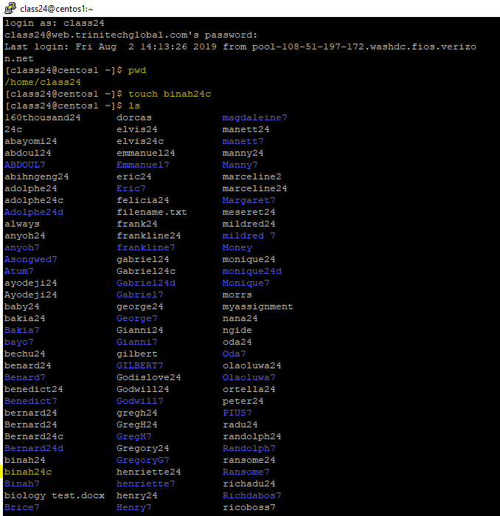

c. Display your current location. What directory are you currently in?

I am in the class24 folder located in the home folder

d. Create a file called yourname24c in your pwd.

Created

e. Display the content of your directory to verify if your file has been created.

Shown

2. Create a document in your Documents folder of your laptop called yourname24d ‘’e.g George24d’’.

Winscp the folder yourname24d from your laptop to the school Centos server.

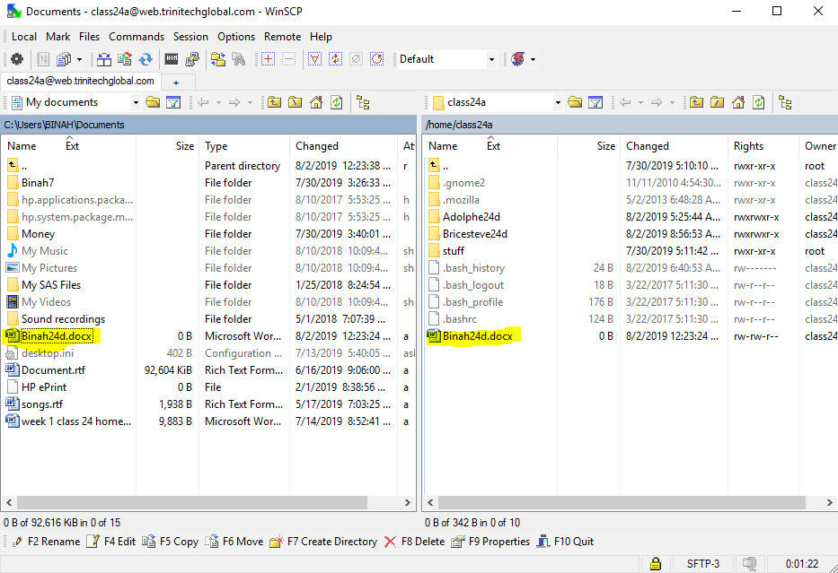

3. Watch the following video and answer the following questions. Hostname should Win10pro24.

a. What category of OS do you have on your laptop?

Wimdows 10 Home

b. Remote Desktop into your Win10Pro24 NOS with a new Admin User Account called admin24

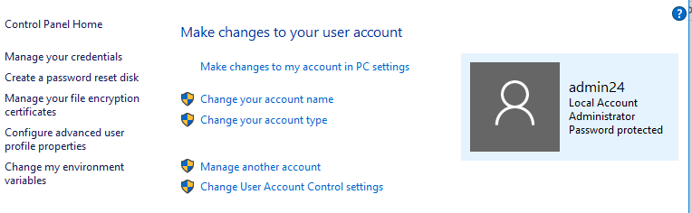

NOTE: If you cannot remote into your NOS, then modify your firewall configuration to grant access to RDP traffic as illustrated by the following [SOP](http://web.trinitechglobal.com:81/school/pluginfile.php/7240/mod_assign/introattachment/0/Open%20RDP%20firewall%20ports%20on%20Windows%2010.pdf?forcedownload=1)

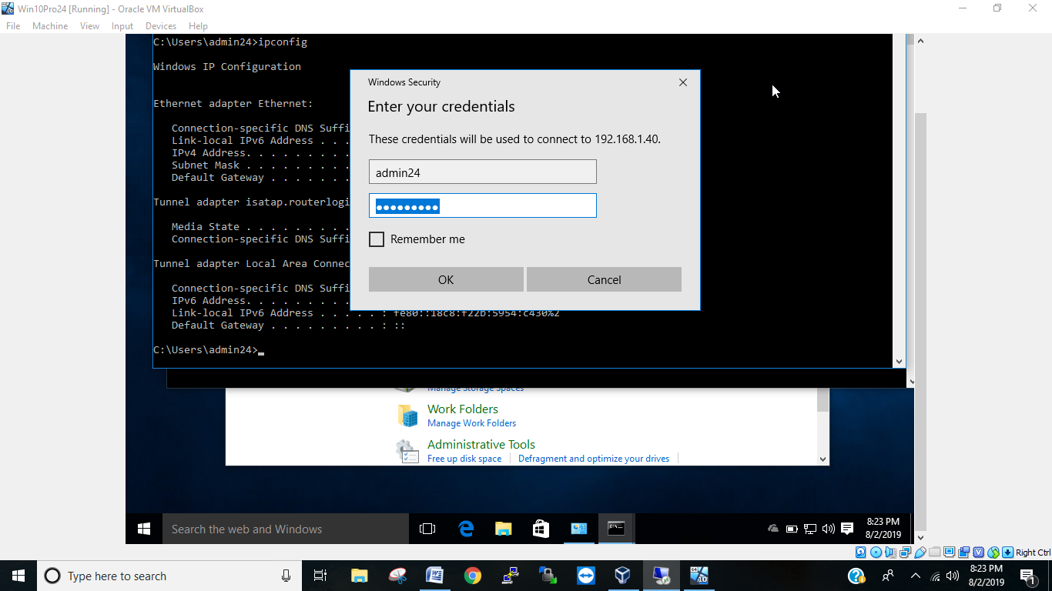

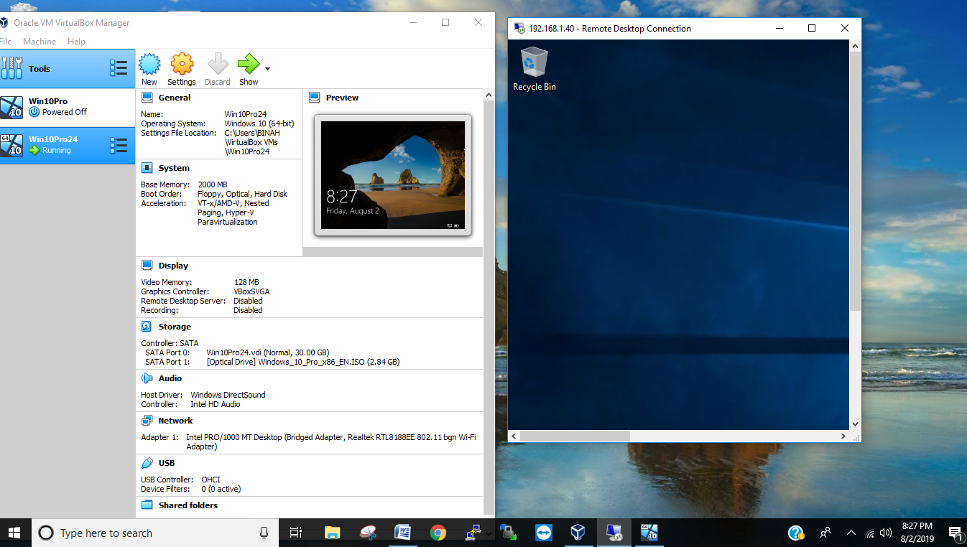

c. Copy the file job.zip from the school Centos server into Admin24 account of your Win10pro24 NOS.

Login Credentials;

Hostname: web.trinitechglobal.com

Login: class24a

Password: school1

File Path: /home/class24a/stuff/job.zip

d. Open the file, read the Desktop support Job description and see if you qualify for the position. (Note you might have to install additional software to be able to view the file)

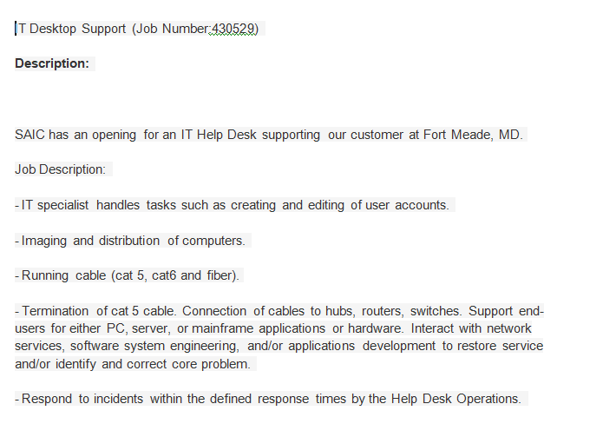

Not so sure if I can handle the role.